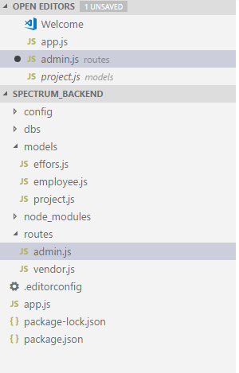

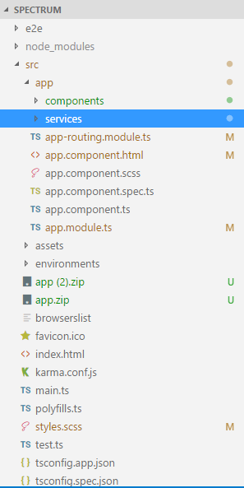



Back end

const express = require('express');

const path = require('path');

const bodyParser = require('body-parser');

const cors = require('cors');

const passport = require('passport');

const mongoose = require('mongoose');

const config = require('./config/database');

const ejs = require('ejs');

const paypal = require('paypal-rest-sdk');

//for gridfs file upload

const crypto = require('crypto');

const multer = require('multer');

const GridFsStorage = require('multer-gridfs-storage');

const Grid = require('gridfs-stream');

const methodOverride = require('method-override');

const MongoClient = require('mongodb').MongoClient;

mongoose.connect(config.database, { useNewUrlParser: true });

//MongoClient.connect(config.database).then(client => client.db)

mongoose.connection.on('connected', () => {

console.log('Connected to database: ' + config.database);

//var gfs = Grid(conn.db);

});

mongoose.connection.on('error', (err) => {

console.log('Database error: ' + err);

});

const app = express();

const admin = require('./routes/admin');

const port = 3000;

app.use(cors());

// Set Static Folder

app.use(express.static(path.join(__dirname, 'public')));

// Body Parser Middleware

app.use(bodyParser.json());

// Passport Middleware

app.use(passport.initialize());

app.use(passport.session());

app.use('/admin', admin);

// Order routes

// Index Route

app.get('/', (req, res) => {

res.send('<h1>VFC APIs</h1> <p>'+

'<b><u>admin - Vendors</u></b><p>' +

'GET /admin/getVendors<br>' +

'DELETE /admin/deleteVendor<br>' +

'POST /admin/addVendor<br>' +

'GET /admin/getVendor/:id<br>' +

'PUT /admin/updateVendor/:id'

);

//res.render('index');

});

app.listen(port, () => {

console.log('Server started on port: ', + port);

});

//Init gfs

package.json

{

"name": "dfc2",

"version": "1.0.0",

"description": "Digital Food Court",

"main": "app.js",

"scripts": {

"test": "echo \"Error: no test specified\" && exit 1"

},

"dependencies": {

"angular-bootstrap-md": "^6.1.1",

"bcryptjs": "^2.4.3",

"body-parser": "^1.18.3",

"cors": "*",

"ejs": "^2.6.1",

"express": "^4.16.3",

"gridfs-stream": "^1.1.1",

"jsonwebtoken": "*",

"mongoose": "*",

"ngx-cookie-service": "^1.0.10",

"passport": "*",

"passport-jwt": "*",

"paypal-rest-sdk": "^1.8.1",

"randomstring": "^1.1.5"

},

"author": "Bhargavi",

"license": "ISC"

}

